**FREE PAD**

A Softwear base on

NoteBook cum DrawingBook

NAME : KAUSTAV HAZRA

FREEPAD is a **C Programming application** called One type of Softwear . It was written base on basic C Programming language.

**Basic Requirement**

1.Turbo c++

2.Code blocks

**Feachers of This Application**

Today is the age of science and we are very busy in our life. Each and every time is very expensive for growing our carrier. So this softwear helps you to reduce (few minutes) the time and its handling is very simple . At the time of implementation of this application I am very carefully for user friendly Because in this softwear we can do two things writing and drawing . Which reduce our time to open wordpad or paint. we can write anything as well as we can draw anything(Free Hand Drawing). As It is base on C Programming so we can use this application at any types of OS like Windows,Mac and Linux . With the help of these headerfile I implement this application.

List of Header File-

1.stdio.h

2.conio.h

3.string.h

4.stdlib.h

5.graphics.h

6.dos.h

7.dirent.h

In user interface there are three options

1. close button.
2. setting button.
3. Directory change button.

Here we can change the color of the text, there are so many color in the user interface .Here dropdown feacher are also available which is more attractive for user. Here we can see a style button from where we can change the font style and as well as we can change the size of the text. We can change the style from normal to bold and italic .Here we can see style button from there we can choice our own style of the text.

Now we are going about drawing . If we want to draw something then we can’t draw in wordpad or m.s office then we have to open paint application . So it consume our time , Atfirst we have to close running application and after that we can open paint application and then we can draw anything(free hand drawing). So here in my application(FREE PAD) we can draw anything (FREE HAND DRAWING) at the same window .

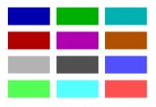We can change the color of the drawing from these button. Here I use graphics for these button so it’s not like a button. And there are a button for eraser so we can erase anything by this button. Here we can draw anything with different color at the same page. We can store all data and drawing at notepad (.txt ) format. This application is more memory efficiency and consume low memory. It’s time complexity is very low. This application size is very less only 79kb.

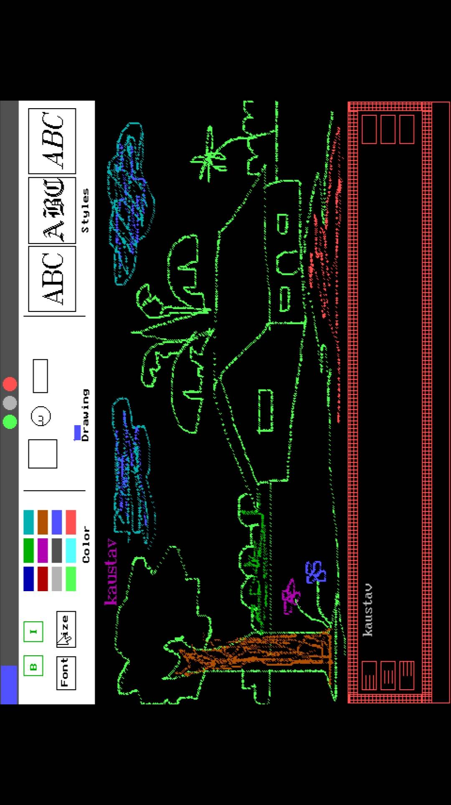

**Future Scope**

In future I also upgrade this application as most as possible user friendly. I try to add some animation and sound in this application . My next vision is to add some extra feacher in setting from there we can change the directory of save file and we can open (.txt file) in my application.